Part A
Name:-
Roll No:-
Subject:- Data Structures and Algorithms
Program: B Tech/MBA Tech CE 2nd Year
Aim:
To study and implement concept of Stack data structure
Prerequisite: C++ Programming
Outcome: To implement parenthesis matching using stack.
- Theory: Stack is a linear data structure which stores the elements in an ordered manner.
- The elements in a stack are added and removed only from one end which is called top.
- The policy is LIFO, the element that was inserted last is the first one to be taken out.
Operations-
- Push(element)- inserts an element at top of the stack
- Pop() – removes the topmost element
- Peek()- returns the topmost element without removing
- isEmpty() – checks if stack is empty
- isFull()- checks if stack is full

Parenthesis matching using stack:
Stacks can be used to check the validity of parentheses in any algebraic expression.
Algebraic expression is valid if for every open bracket there is a corresponding closing bracket.
For example, the expression (A+B} is invalid but an expression {A + (B – C)} is valid.

Algorithm
Parenthesischeck( string)
{
valid= true;
s= the empty stack;
while ( entire string is not read)
{
symb=next symbol of the string;
if (symb == ‘(‘ || symb == ‘{‘|| symb == ‘[‘)
push (symb)
else if (symb == ‘)‘ || symb == ‘}‘|| symb == ‘]‘)
{
i= pop ();
if ( i is not the matching opener of symb)
valid=false
} //end else
} //end while
if (stack s not empty)
valid=false
if (valid) print (“the string is valid”);
else print (“the string is not valid”);
}

Procedure:
- Open CodeBlock editor or visual studio editor and write the code in C++.
- Complile and run the code
Instructions:

- Copy code & paste in code section and output of Part B.

Part B
Code:
#include <iostream>
#include <string>

using namespace std;

class Stack {
char stack[1000];
int top;

public:
Stack() {
top = -1;
}

void push(char c) {
if (top < 999) {
stack[++top] = c;
} else {
cout << "Stack overflow\n";
}
}

char pop() {
if (top >= 0) {
return stack[top--];
} else {
return '\0';
}
}

bool isEmpty() {
return top == -1;
}
};

bool isMatchingPair(char opener, char closer) {
if (opener == '(' && closer == ')') return true;
if (opener == '{' && closer == '}') return true;
if (opener == '[' && closer == ']') return true;
return false;
}

bool ParenthesisCheck(const string &str) {
Stack s;
bool valid = true;
int i=0;
while (i < (int)str.length()) {
char symb = str[i];
if (symb == '(' || symb == '{' || symb == '[') {
s.push(symb);
} else if (symb == ')' || symb == '}' || symb == ']') {
char opener = s.pop();
if (!isMatchingPair(opener, symb)) {
valid = false;
break;
}
}
i++;
}

if (!s.isEmpty()) {
valid = false;
}

return valid;
}

int main() {
string input;

cout << "Enter a string with parentheses: ";
getline(cin, input);

if (ParenthesisCheck(input)) {
cout << "The string is valid.\n";
} else {
cout << "The string is not valid.\n";
}

return 0;
}

Output:
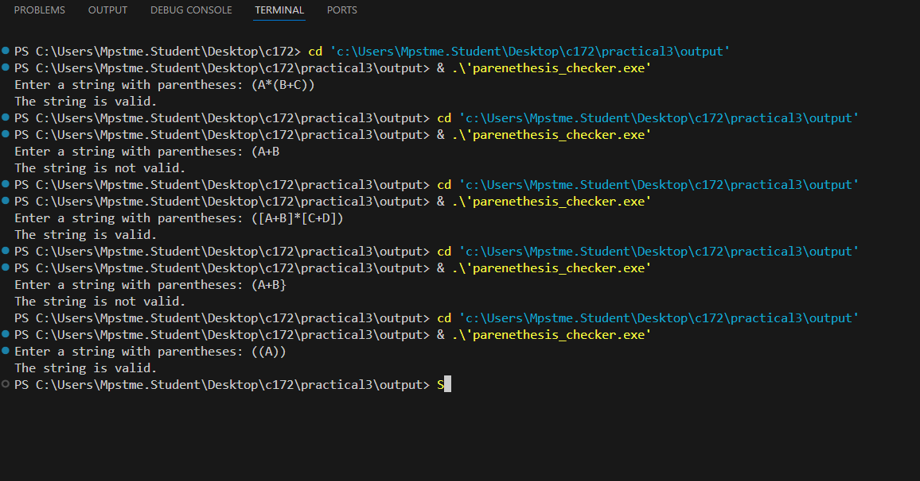
Observation & Learning:
Write your Observations & Learning after performing task
Answer Following Question
Simulate the parenthesis checker algorithm for each of the following strings by showing the contents of the stack at each point-
- {A + (B – C)}
- (A + B)) * C

1.
Step | Character | Action | Stack Content
1 | { | Push | {
2 | A | Ignore | {
3 |  | Ignore | {
4 | + | Ignore | {
5 |  | Ignore | {
6 | ( | Push ( | { , (
7 | B | Ignore | {, (
8 |  | Ignore | {, (
9 | - | Ignore | {, (
10 |  | Ignore | {, (
11 | C | Ignore | {, (
12 | ) | Pop ( (matches )) | {
13 | } | Pop {(matches }) | Empty

Stack is empty → Valid string

2.
Step | Character | Action | Stack Content
1 | ( | Push | (
2 | A | Ignore | (
3 | + | Ignore | (
4 | B | Ignore | (
5 | ) | Pop | Empty
6 | ) |  | )
7 | * |  | )
8 | C | Ignore | )

Stack is not empty -> Invalid string
Conclusion:
We successfully implemented C++ program for parenthesis check using stack

